**Domain and Ad Hoc View for the nested Table in BigQuery**

1. data source:



1. select kafka_test schema:

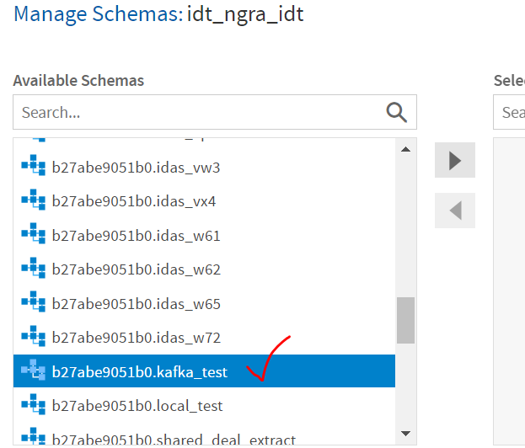

1. select test_nested_jason table:

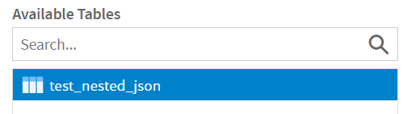

1. drag and drop all fields in Data Presentation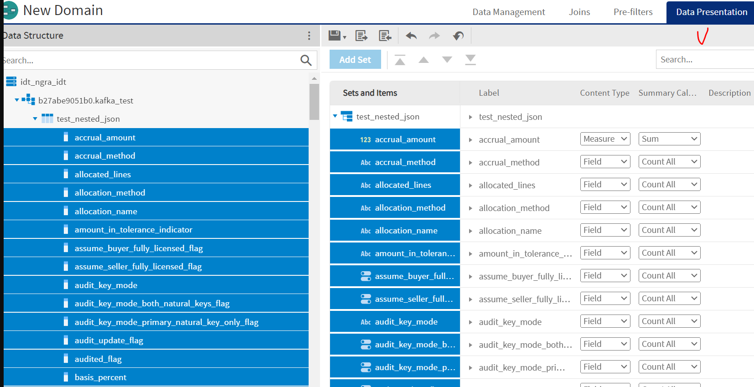
2. save domain in repository:
3. 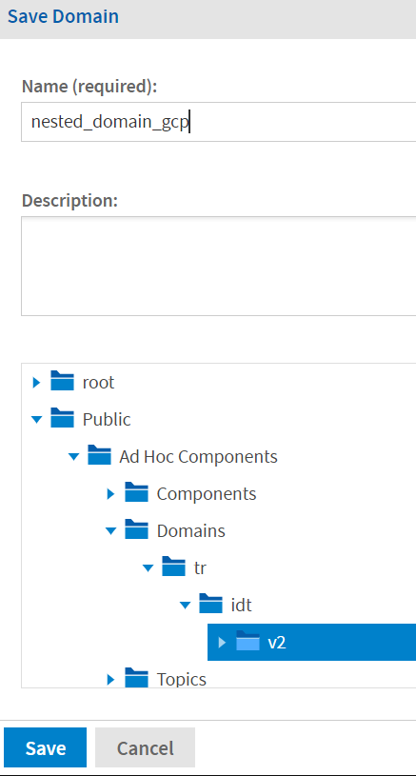
4. create an ad hoc view from this domain:

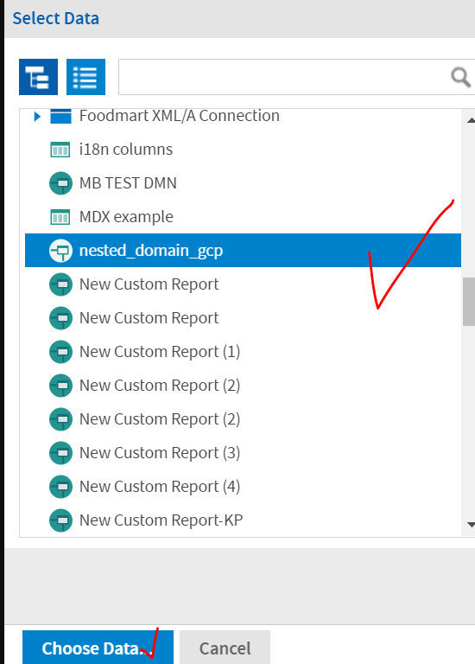

1. select all fields:

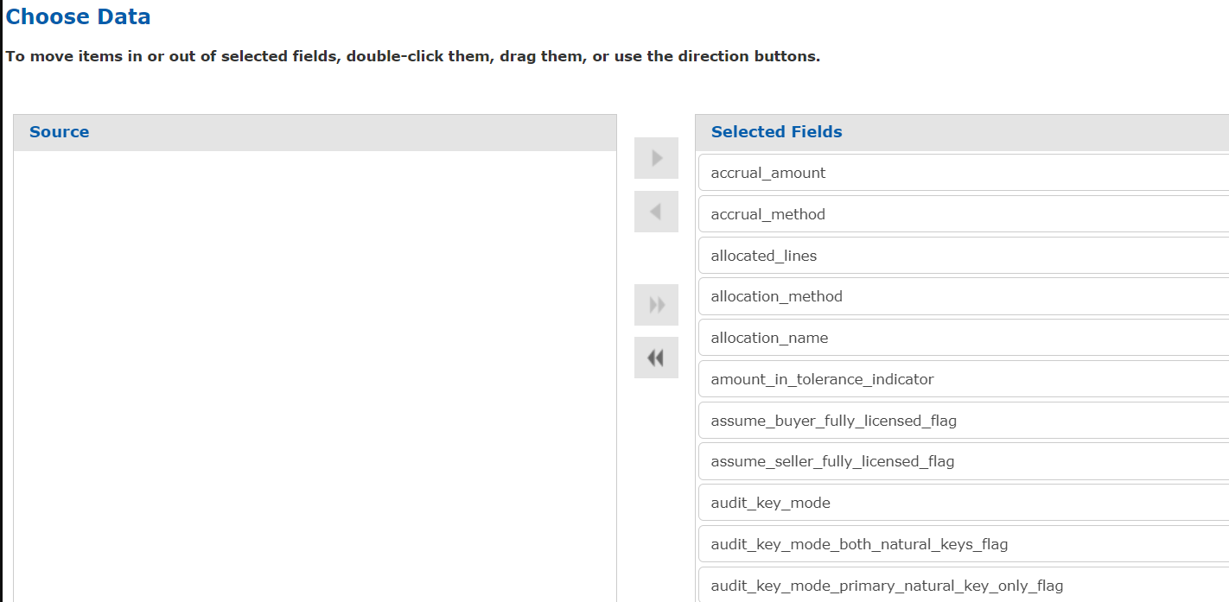

1. ad doc view doesn't show structure for line_items.

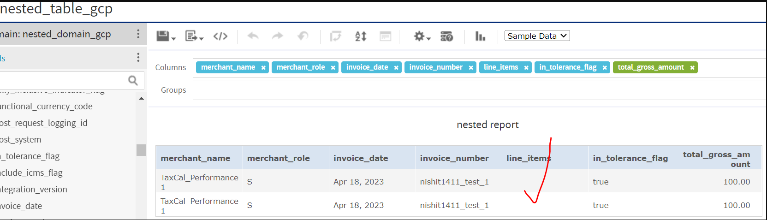

1. when looked into this table in BQ,, line_items shows  a nested fields

