**Scheduling - Output to Host File System with dynamic default values**

Hello,

We want to give default value to "Output to Host File" option depending on logged in user profile, while scheduling the report.

Means when a user selects "Output to Host File" option, then default value should be there as per his profile.

User needs not to enter any value manually there, it should automatically come as per his profile

**Check below two examples, to understand our requirement**

**Example-1:**

If **User1** of organization-1 logs in then the default value for "Output to Host File" will be **“/org1”**

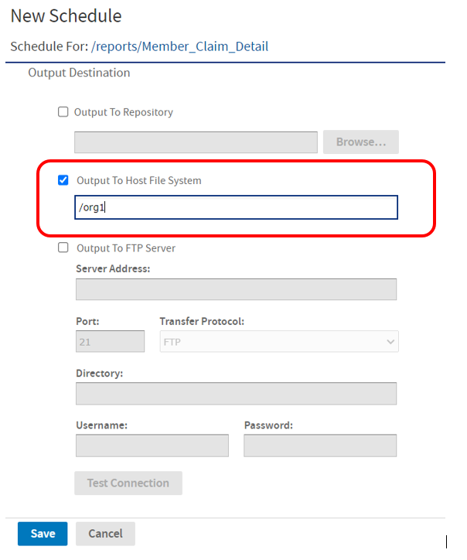

**Example-2**

If **User2** of organization-2 logs in then the default value for "Output to Host File" will be **“/org2”**

