Calculated Measure – Able to add a **RunningTotal** function

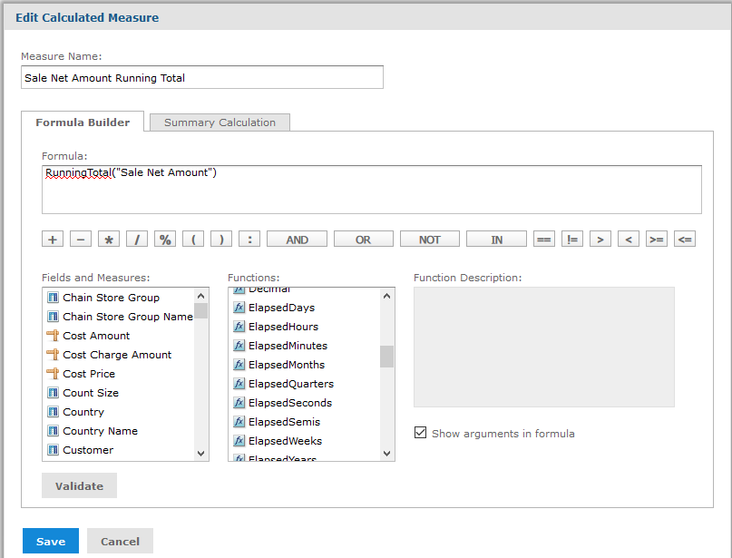

What it should be able to is to keep a running total for the measure for each following month in this example, the Sale Net Amount.

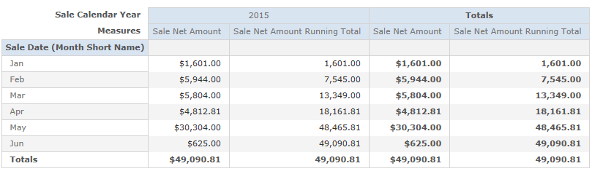

And we can see this in a Chart.

