23244469 summary filter
Standard table report, showing a list of purchase orders from our Purchase to Pay domain:
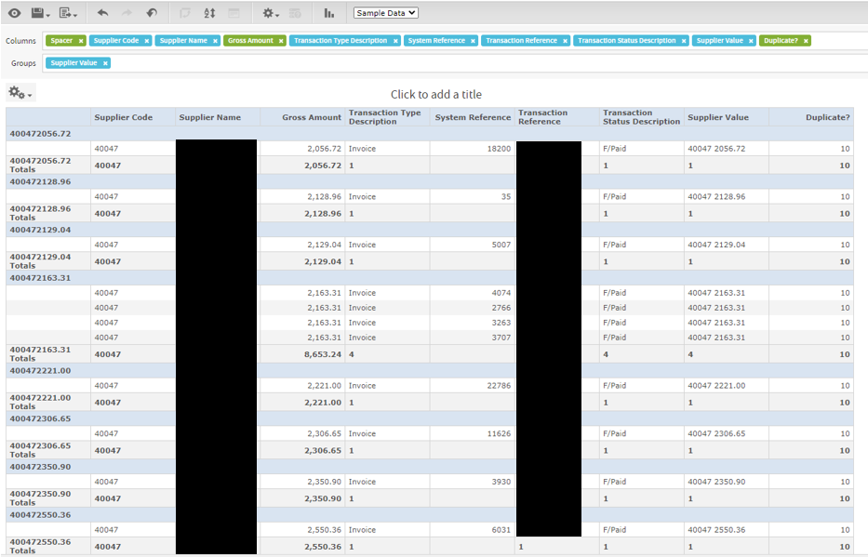
You can see that for Supplier Code 40047, there are 4 rows for the GROUPED calculated field of “Supplier Value” of “40047 2163.31”, but only one row for all the others. I could have used a number of fields (calculated or otherwise, on which to group, that’s not important).
If I set the report to show totals only, I get this:
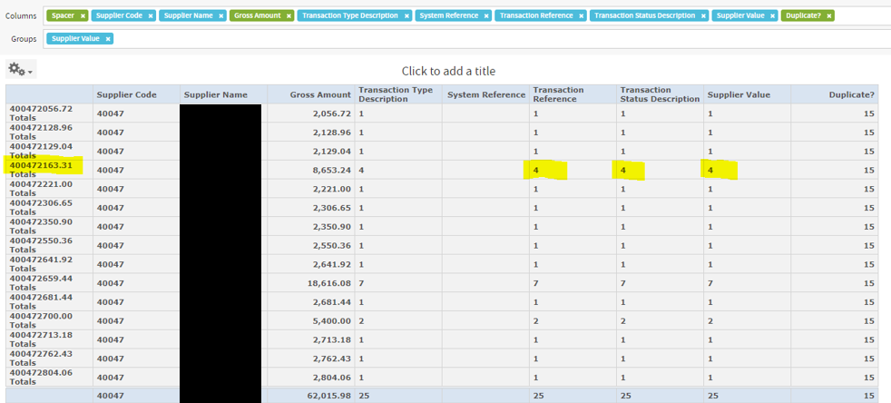
I have highlighted the grouping which has 4 rows summarised.
My requirement is to be able to filter on the summary value of 4, ie a filter where “Supplier Value”=4.

